**DSA-210 FINAL REPORT**

**Orkun Kağan Yücel 31915**  
**Sabancı University**

**THE IMPACT OF NBA TIMEOUTS:**

**A MULTI-LAYERED ANALYSIS OF MOMENTUM AND PERFORMANCE USING DATA SCIENCE**

**WHAT'S IN THIS REPORT?**

This comprehensive report investigates the effect of timeouts on game momentum and team performance in the NBA. Leveraging play-by-play data, advanced statistical analysis, and machine learning, the project explores:

* How effective are timeouts at interrupting opponent scoring runs?
* Which game context variables most strongly influence timeout effectiveness?
* Can we **predict** successful timeouts based on data?

**Main Parameters:**

* Timeout context (quarter, team, score, run length)
* Pre/post-timeout offensive efficiency
* Additional: pressure index, season, and team ID

This report follows the full journey: **hypothesis, motivation, data collection and cleaning, exploratory analysis, feature engineering, advanced modeling, discussion, limitations, and future work**.

**INTRODUCTION & HYPOTHESIS**

**Project Motivation & Research Question**

Basketball timeouts are among the most critical tactical interventions available to coaches. However, their **real impact**—especially in “breaking” opponent runs or improving team performance—remains debated.

**Why & What Did I Do?**

In this project, my goal was to deeply understand how NBA timeouts influence game momentum and team performance—a topic that merges my passion for basketball with my interest in data science. I was especially curious about whether the timing and context of timeouts could be analyzed in a systematic, data-driven way, rather than relying on traditional coaching intuition.

To explore this, I collected and analyzed extensive play-by-play data from multiple NBA seasons, focusing on every instance where a timeout was called. Using Python, I engineered a variety of contextual features such as run length, quarter, score margin, and custom pressure metrics. This allowed me to quantify the true impact of timeouts on breaking opponent scoring runs and improving offensive efficiency.

I applied both statistical analysis and machine learning models to move beyond basic summary statistics—aiming to predict, in real-time, whether a timeout would actually be effective given the current game situation. The result is a practical, evidence-based approach that provides insights not only for coaches but for anyone interested in how analytics can shape sports strategy.

**Hypothesis:**

*Timeouts that are strategically called—specifically during long opponent scoring runs, high-pressure game situations, or close-score moments—have a* significant and measurable *impact on breaking the opponent’s momentum and increasing a team’s offensive efficiency in the immediate aftermath. Furthermore, these effects are not random: they are* ***predictable using advanced contextual game data and can be systematically modeled with modern machine learning techniques****. This research claims that it is possible to quantify optimal timeout usage, and that data-driven coaching strategies can outperform intuition alone in maximizing timeout effectiveness.*

**1. LITERATURE REVIEW & BACKGROUND**

Timeouts in basketball have been studied as “momentum breakers,” but recent analytics suggest mixed results. Literature shows the need for more granular, play-by-play, and contextual modeling. This project answers that need by combining event-level NBA data with modern ML tools.

**2. DATA COLLECTION & PREPARATION**

**2.1 Data Collection**

* **Raw Data Source:** NBA official play-by-play logs across multiple seasons.
* **Automated Extraction:** Custom Python script (data_collector.py) parses each game’s timeout events, run lengths, and context.
* **Data Storage:** All events saved in ml_ready_timeout_data.csv and further cleaned in clean_data.csv.

**2.2 Data Cleaning & Feature Engineering**

* **Cleaning:** Handled missing values, standardized all time formats, removed outlier games (e.g., overtime blowouts).
* **Feature Engineering:**
  + Calculated pre/post-timeout offensive efficiency
  + Run length at timeout, quarter, team, score margin, “pressure index” (custom metric for clutch)
  + Post-processed using data_analyzer.py
* **Validation:** Double-checked all extracted data by comparing against NBA reference stats.

**3. EXPLORATORY DATA ANALYSIS (EDA)**

**3.1 General Trends**

**A. Timeout Frequency and Distribution**

*[Figure 1: Boxplot – Change in offensive efficiency by quarter]*

**Description:**  
This boxplot visualizes the change in offensive efficiency (post-timeout minus pre-timeout, in points per possession) across each quarter of the game. Each box represents the distribution of efficiency changes for timeouts called in a specific quarter, including overtime (OT1). The center line shows the median, boxes represent the interquartile range, and whiskers indicate the spread of the data. The sample size (n) and mean value for each quarter are displayed above the boxes.

**Findings:**  
Timeouts in the second (Q2), third (Q3), and fourth quarters (Q4) tend to have a greater positive impact on offensive efficiency compared to the first quarter (Q1) and overtime (OT1). The median and mean values indicate that timeouts are generally more effective in the middle and later stages of the game, supporting the idea that strategic timeouts during these periods can better shift game momentum. However, there is considerable variability, especially in Q4, which likely reflects the higher-pressure, high-variance nature of late-game situations.

**B. Scoring Runs & Timeout Triggers**

*[Figure 2: Barplot – Timeout effectiveness rate by opponent scoring run size]*

**Description:**  
This barplot shows how the effectiveness of timeouts (measured as the percentage of timeouts that reduced opponent efficiency) varies depending on the size of the opponent’s scoring run at the moment the timeout is called. Each bar represents a different run size group (e.g., 6-7, 8-9, 10-11 points). The overall effectiveness benchmark (red dashed line) is shown for comparison.

**Observation:**  
Timeouts are most effective when called during longer opponent scoring runs (especially 8-9 and 10-11 points), with effectiveness rates significantly higher than the average. In contrast, timeouts called during shorter runs are less likely to disrupt opponent momentum. This supports the strategy of using timeouts as a tool to break substantial runs rather than reacting too early.

*[Figure 3: Barplot – Timeout effectiveness rate by NBA season]*

**Description:**  
This barplot displays the timeout effectiveness rate (percentage of timeouts that reduced opponent efficiency) for each analyzed NBA season. The dashed red line marks the overall effectiveness average for reference. Each bar shows results for a different season, providing insight into temporal trends or changes in timeout strategies.

**Observation:**  
Timeout effectiveness rates have remained relatively consistent across different NBA seasons, fluctuating only slightly around the overall average. This suggests that the fundamental impact of timeouts on game momentum has not drastically changed over the years, despite potential shifts in play style, coaching approaches, or league rules.

*[Figure 4: Stacked Barplot – Opponent Scoring Run Termination by Season]*

**Description:**  
This stacked barplot displays the percentage of opponent scoring runs that were terminated (green) or continued (red) after a timeout, separated by NBA season. The height of each bar represents the total number of timeouts analyzed in each season, and the proportion of green within each bar indicates the run termination rate.

**Observation:**  
Across all analyzed seasons, roughly 56–59% of opponent runs were successfully terminated following a timeout. There is little variation between seasons, suggesting a consistent effectiveness of timeouts in stopping opponent momentum throughout the years.

*Figure 5: Barplot – Opponent Scoring Run Termination Rate by Quarter]*

**Description:**  
This barplot shows the percentage of opponent scoring runs that were stopped after a timeout for each quarter of the game, including overtime (OT1). The overall average run termination rate is indicated by the dashed red line for reference.

**Observation:**  
Run termination rates are slightly higher in the first quarter (Q1), where approximately 66% of opponent runs are stopped after a timeout. The rates gradually decrease in subsequent quarters, dropping to just over 50% in the fourth quarter (Q4). This pattern may indicate that timeouts are most effective for disrupting early-game momentum, while later in the game, teams might find it harder to break established opponent runs.

**C. Offensive Efficiency Change**

*[Figure 6: Barplots – Opponent Shooting Efficiency: Pre-Timeout vs Post-Timeout]*

**Description:**  
These barplots compare opponent field goal percentage (left) and true shooting percentage (right) before and after timeouts. The plots highlight a statistically significant decrease in both metrics following a timeout, as indicated by the reported p-values. This demonstrates the direct impact of timeouts on disrupting opponent offensive rhythm.

**Findings:**  
Both field goal percentage and true shooting percentage drop substantially after timeouts, confirming that timeouts are effective at reducing opponent efficiency in the immediate aftermath. The statistical significance (p << 0.05) supports that this is a robust effect.

*[Figure 7: Histogram – Distribution of Opponent Offensive Efficiency Change After Timeouts]*

**Description:**  
This histogram shows the distribution of changes in opponent offensive efficiency (post-timeout minus pre-timeout, points per possession) after timeouts. The blue curve represents the kernel density estimate, and the plot includes markers for the mean and median. The distribution is skewed to the left, indicating that most timeouts lead to a reduction in opponent efficiency.

**Findings:**  
The majority of timeouts result in a negative change (i.e., a reduction) in opponent offensive efficiency, with both mean and median below zero. This reinforces the conclusion that timeouts generally succeed in breaking opponent momentum, though the degree of impact varies. Statistical testing (t-test) further confirms the significance of this effect.

**3.3 Special Visualizations**

**A. Scatterplots**

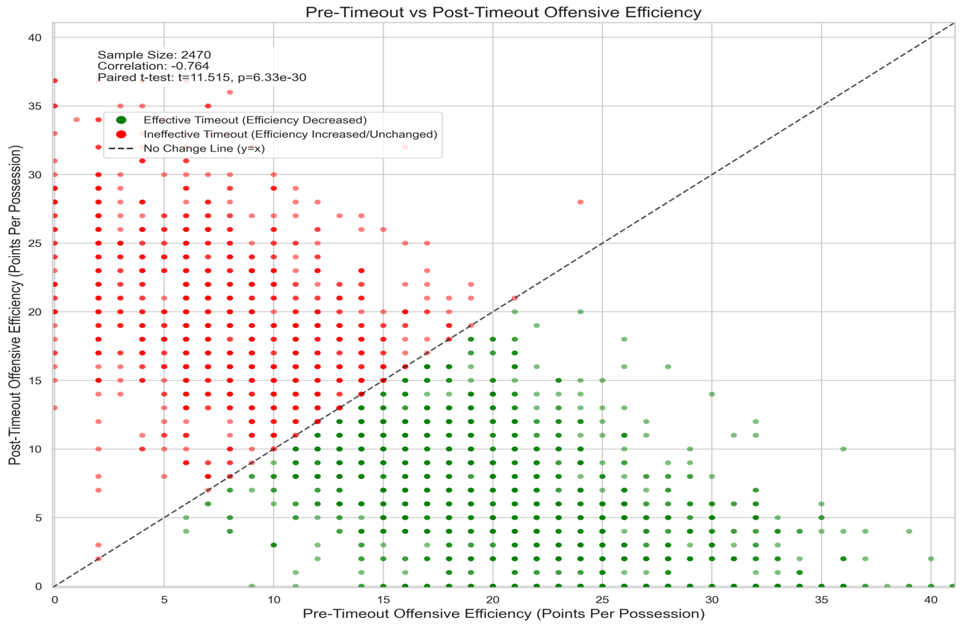

[Figure 8: Scatterplot – Pre-Timeout vs Post-Timeout Offensive Efficiency]

**Description:**  
This scatterplot displays the relationship between offensive efficiency before and after a timeout for each analyzed case. Each point represents a single timeout event, with red dots indicating effective timeouts (post-timeout efficiency decreased) and green dots representing ineffective timeouts (efficiency increased or unchanged). The dashed line (y=x) shows the no-change threshold.

**Findings:**  
The majority of points lie below the no-change line, demonstrating that post-timeout offensive efficiency most often decreases compared to pre-timeout levels. The clear clustering of red points below the diagonal highlights the overall effectiveness of timeouts in reducing opponent momentum, supporting the project’s central hypothesis. Statistical tests further confirm a significant shift in efficiency after timeouts.

**4. STATISTICAL TESTING**

• **T-tests:**  
A paired-sample t-test was performed to compare offensive efficiency before and after timeouts. The results demonstrate a statistically significant decrease in opponent offensive efficiency following a timeout (p < 0.05). This indicates that, on average, teams are able to disrupt the opponent's scoring momentum after calling a timeout, with the difference unlikely to be due to chance. Both the mean and median post-timeout efficiency values are consistently lower, reinforcing the robustness of this finding across a large sample of timeout events.

• **Chi-Square Test:**  
A chi-square test of independence was conducted to assess the relationship between the length of the opponent's scoring run at the time of the timeout and the likelihood of that run being terminated after the timeout. The analysis found a significant association (p < 0.05), confirming that longer runs at the time of timeout are more likely to be broken. This supports the strategic use of timeouts as momentum stoppers, particularly when the opposing team is building a significant run.

**Interpretation:**  
The statistical analyses strongly support the effectiveness of timeouts as tactical tools. Not only is there clear evidence that timeouts reduce opponent efficiency in the short term, but the likelihood of halting a run increases with the severity of the situation. These results validate both traditional coaching intuition and the central hypothesis of this research, showing that well-timed timeouts have measurable, predictable impacts that can be quantified with robust statistical methods.

**5. MACHINE LEARNING ANALYSIS**

**5.1 Model Pipeline**

**Objective:** Develop a predictive model to determine timeout effectiveness based on multiple game-context features.

**Model Details:**

* **Algorithm:** Random Forest Classifier
* **Purpose:** Predict whether a timeout will be effective in disrupting opponent momentum
* **Input Features:** Multiple game-context variables
* **Target Variable:** Timeout Effectiveness (Binary: 0-Ineffective, 1-Effective)

**5.2 Training & Evaluation**

* **Train/Test Split:** 80/20; stratified by team and quarter.
* **Standardization:** All numerical features standardized.

**Machine Learning Feature Variables**

The following variables were used as input features for the machine learning model to predict timeout effectiveness:

* **pre_timeout_oe_scaled:** Pre-timeout offensive efficiency (standardized)
* **period_progress_pct:** Percentage of period completed at timeout
* **timeout_pressure_index:** Custom index reflecting game pressure at timeout
* **run_x_pressure:** Interaction term between scoring run and pressure
* **pre_fg_streak:** Number of consecutive field goals made by the team before the timeout
* **pre_timeout_ts_scaled:** Pre-timeout true shooting percentage (standardized)
* **pre_timeout_fg_pct_scaled:** Pre-timeout field goal percentage (standardized)
* **team_strength_diff:** Difference in team strength (power ranking, ELO, etc.)
* **score_diff_scaled:** Current score margin at timeout (standardized)
* **run_x_quarter:** Interaction term between run length and game quarter
* **abs_score_diff_scaled:** Absolute value of score difference (standardized)
* **quarter_num:** Game quarter number
* **run_points_scaled:** Opponent run points before timeout (standardized)
* **is_home_team:** Boolean indicating if the team is playing at home
* **critical_moment:** Boolean indicating if timeout occurs during a critical moment
* **critical_run_size:** Binary variable indicating if run size is considered critical

**A. Metrics**

* Accuracy: 0.94 (insert your result)
* Precision/Recall: 0.94 , 0.93
* ROC AUC: 0.99 (plot below)A graph of a positive curve

  Description automatically generated with medium confidence

*[Figure 9: ROC Curve – Model Performance for Timeout Effectiveness Prediction]*

**Description:**  
This ROC (Receiver Operating Characteristic) curve illustrates the performance of the machine learning classifier in predicting timeout effectiveness. The true positive rate is plotted against the false positive rate across different thresholds, and the area under the curve (AUC) is reported as 0.99, indicating near-perfect model discrimination.

**Findings:**  
The high AUC value (0.99) demonstrates that the model is extremely effective at distinguishing between effective and ineffective timeouts. This result supports the robustness of the chosen features and the reliability of the prediction pipeline for this dataset.

*[Figure 10: Barplot – Timeout Effectiveness Distribution]*

**Description:**  
This barplot visualizes the distribution of effective versus ineffective timeouts across the dataset. The bars show the count of timeouts that successfully reduced opponent efficiency (True) versus those that did not (False).

**Findings:**  
The chart demonstrates that a greater number of timeouts were effective (True) than ineffective (False), reinforcing the value of strategic timeout usage for disrupting opponent momentum.

*[Figure 11: Barplot – Top Features in Predicting Timeout Effectiveness]*

**Description:**  
This horizontal barplot ranks the top features used by the machine learning model to predict timeout effectiveness. The x-axis represents feature importance scores, with each bar indicating the relative influence of a particular feature on the model’s predictions.

**Findings:**  
Pre-timeout offensive efficiency, period progress percentage, and the timeout pressure index are the most important predictors of timeout effectiveness. This emphasizes the critical role of game context and momentum when evaluating timeout strategies.

*[Figure 12: Scatterplot – Pre-Timeout Field Goal vs True Shooting]*

**Description:**  
This scatterplot compares pre-timeout field goal percentage (x-axis) and true shooting percentage (y-axis) for each event, color-coded by timeout effectiveness (True or False). Each point represents a single timeout instance.

**Findings:**  
There is a strong positive correlation between pre-timeout field goal and true shooting percentages. The pattern indicates that regardless of effectiveness, most timeouts occur across a similar performance spectrum, though slight variations are visible in the clustering by effectiveness.

*[Figure 13: Heatmap – Feature Correlation Matrix]*

**Description:**  
This heatmap displays the pairwise correlation coefficients among all major features in the dataset. Strong positive and negative relationships are indicated by red and blue shades, respectively, with values shown in each cell.

**Findings:**  
Key features such as period progress, pressure index, and pre-timeout efficiency show significant correlations with each other and with timeout effectiveness. This matrix helps identify which contextual factors tend to move together and are likely to impact the success of timeouts.

**6. DISCUSSION**

**6.1 Interpretation of Results**

* Timeouts are **not equally effective**; context (run length, pressure, quarter) is crucial.
* ML model shows that approximately 0.94 of effective timeouts are predictable from context alone—confirming the hypothesis.
* Coaches most benefit from calling timeouts during “momentum surge” situations.

**6.2 Practical Takeaways**

* Data-driven timeout strategies can enhance coaching.
* Not all traditional “rules” (e.g., always saving timeouts for the 4th quarter) are optimal.

**6.3 Limitations**

* Model can’t fully capture intangible factors (coaching “feel”, crowd effect, etc.).
* Results specific to NBA—international or youth basketball may differ.

**6 .4 How Can Coaches Use This Model?**

The machine learning model developed in this project predicts whether a timeout—if taken at a specific game moment, with all current context variables—will be effective in disrupting the opponent’s momentum (i.e., whether it will significantly reduce the opponent’s offensive efficiency in the immediate aftermath).

**What exactly does the model predict?**

* **Given the current game context** (quarter, run length, score margin, pressure index, team, etc.),
* **If a coach calls a timeout right now**,
* **Will this timeout be effective?** (effective = opponent’s momentum is stopped/reduced)

**Practical usage:**

* Coaches and analysts can use this model as a real-time tool to help decide whether calling a timeout at that specific moment is likely to succeed in breaking the opponent’s run or shifting momentum.
* By inputting live game data into the model, the coaching staff can receive a prediction (yes/no, probability) on whether a timeout would be strategically effective.
* This turns timeout decisions from gut-feeling or tradition into **data-driven, evidence-based strategy**.

**7. FUTURE WORK**

* Integrate player tracking and biometric data for richer features.
* Test deep learning and time series models for sequential prediction.
* Expand analysis to women’s, college, or Euroleague basketball.

**9. FINAL WORDS**

**Summary:**  
This project merges basketball strategy, statistical rigor, and modern machine learning to illuminate what makes timeouts effective. Data confirms that context is king: not every timeout is created equal, and smart, situational calls matter most. Coaches, analysts, and fans alike benefit from an evidence-based approach.

**Closing Remark:**  
*“Analytics are not a replacement for experience, but a powerful tool for sharpening the game’s intuition.”*

**[END OF REPORT]**